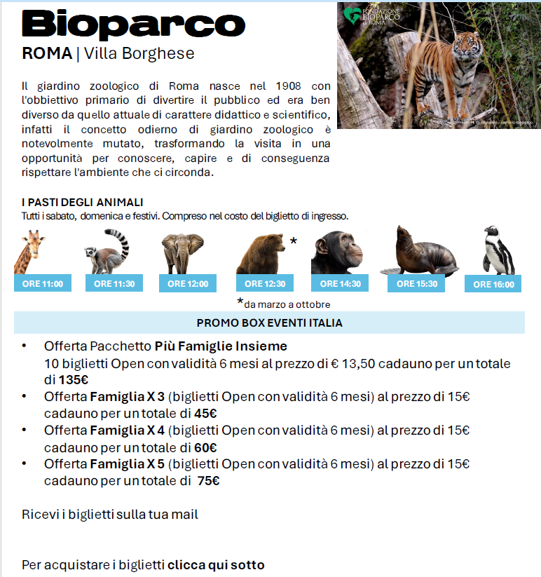
https://docs.google.com/forms/d/e/1FAIpQLSf424qEmSg8bWxAKuAVlxidOmM9m3P7Ky0dCad4NRUpeGljjg/viewform

