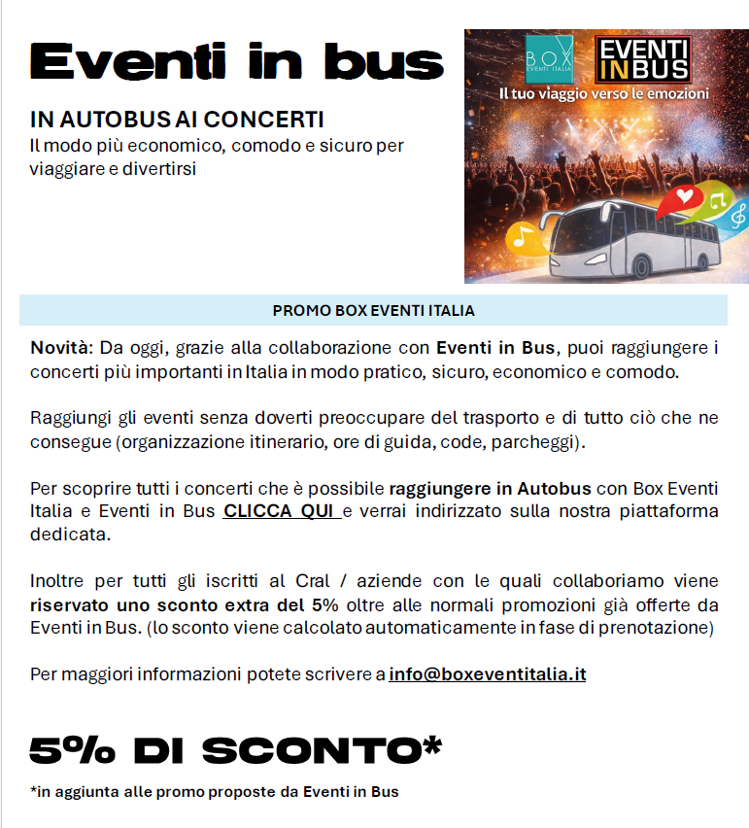
partner.eventinbus.com/partner/landing/boxeventiitalia

